Helmshore Debris Screen, EA

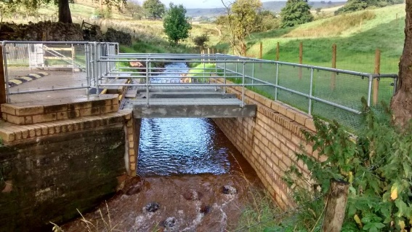
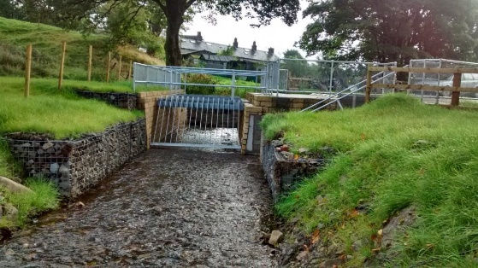
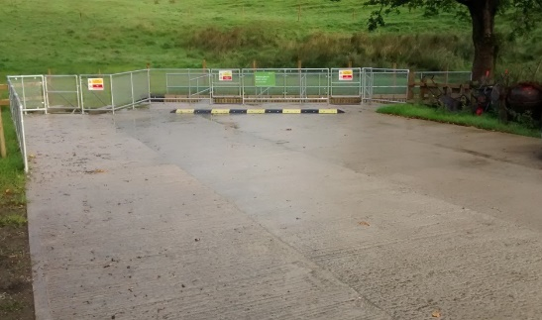
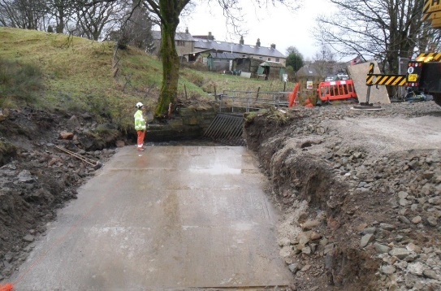
Client: | Environment Agency
Nature of the works: | Environmental Works, In Channel River Works
Scope & Service provided: | Install a new precast concrete channel to enable installation of a new debris screen with and access bridges within the existing river channel alignment to alleviate potential flooding risk to properties further downstream.
Value & Duration: | The works involved  - Undertake FRAP licence application for all temporary and permanent works structures.  - Diversion of the live river flows via an purpose made temporary river channel.  - Excavation of the existing river channel and construction of an insitu concrete foundation slab to accept the precast concrete channel sections.  - Supply and installation of precast concrete channel units, including preparation of lifting plans.  - Stone work facing to the precast concrete channel walls so to be sympathetic with the surrounding area.  - Installation of Gabion Basket river channel retaining to discourage erosion of the embankments upstream of the debris screen.  - Procurement of steel debris screen, assess bridge and hand rails.  - Construction of concrete slabs to facilitate parking and HGV access to enable mechanical clearing of the debris screen during high river flows  £130,000 over a 6-week period

